3rd Generation Partnership Project (3GPP)
4G: LTE – 2008 (Long Term Evolution)
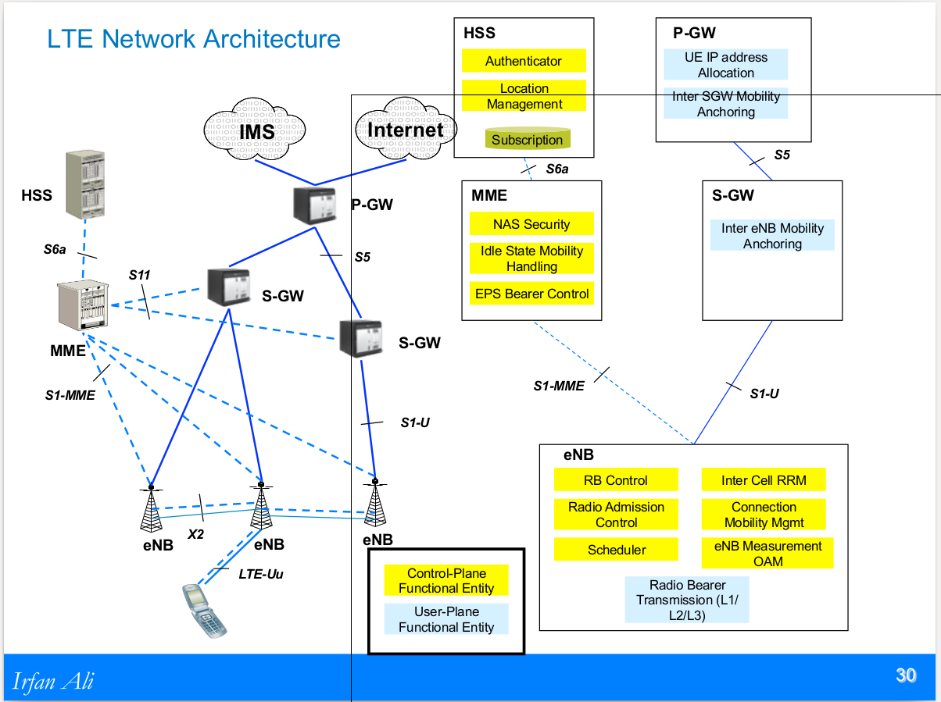
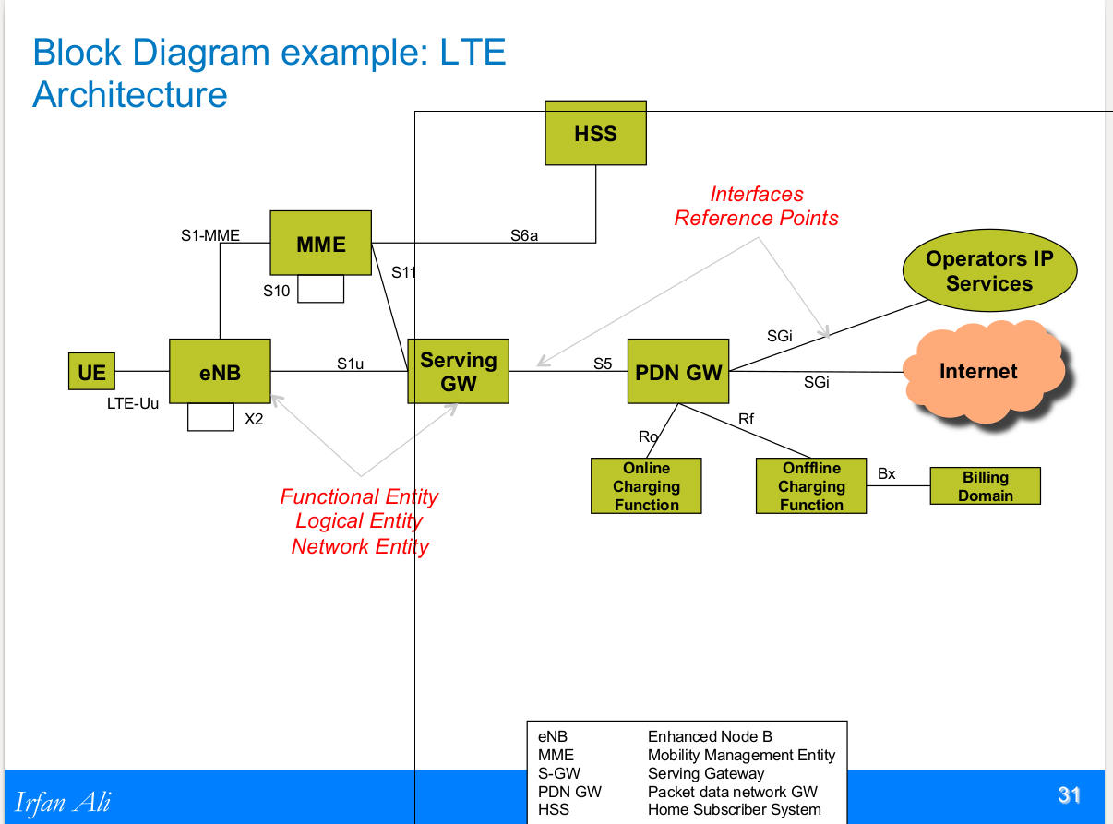
there is control-plane and user- plane separation Æ MME is the control-plane entity. Æ SGW and PGW are the user-plane entity

The UE performs control communication (signalling) with two nodes in the network:
eNB via the Radio Resource Control (RRC) protocol. This is called the access-stratum
MME via the Non-access-stratum protocol.

A mobile operator’s network is also known as a Public Land Mobile Network (PLMN).
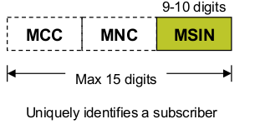
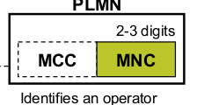

The goal of “attaching” to the network is to obtain an IP address to communicate with outside world. The UE is authenticated and authorized to use send/receive data.
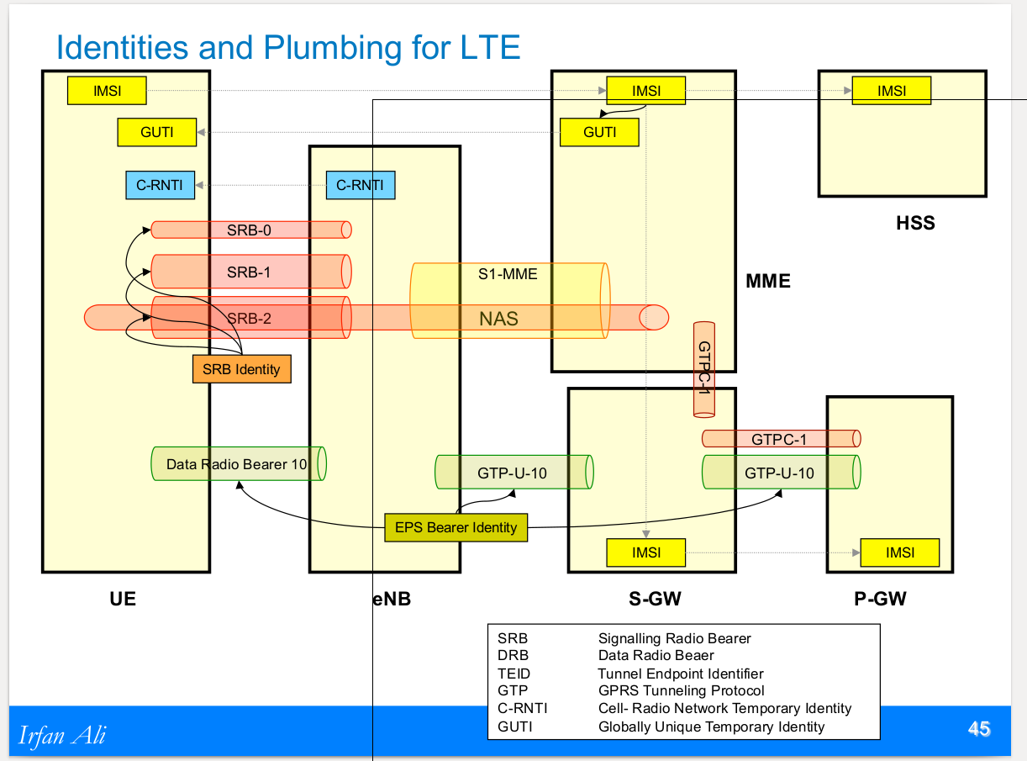

GTP=GPRS Tunneling Protocol Route an IP packet along a path that is not topologically correct for the packet.
Signaling part called GTP-C (GTP-Control)
User data part called GTP-U (GTP-User)

OFDM: Orthogonal Frequency Division Multiplexing
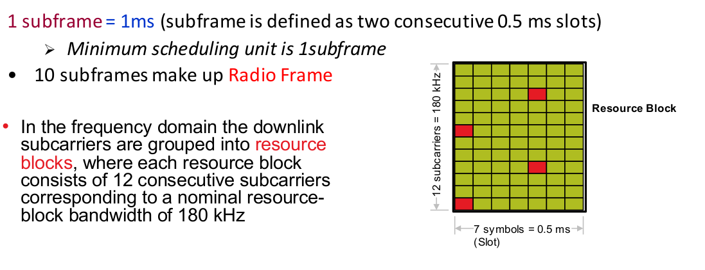

The sending node is called Correspondent Node (CN)
The moving node is called mobile node (MN)
One of the main goals of mobility solution is to provide “seamless” session continuity
An application on a fixed correspondent node (CN)desired to maintain its application session(eg.voice) with a mobile node (MN) whose IP point of attachment to the network changes during the application session.
IP Layer based Mobility Solution
1. Routing-update based solutions
2. Tunneling/Mapping based solution (GTP, MIP)
Identifier: A stable value used to identify a mobile node which does not change as the MN moves around
Locator: The IP address of the MN’s current point of attachment to the network. It is the topologically correct subnetwork address of where the mobile is.
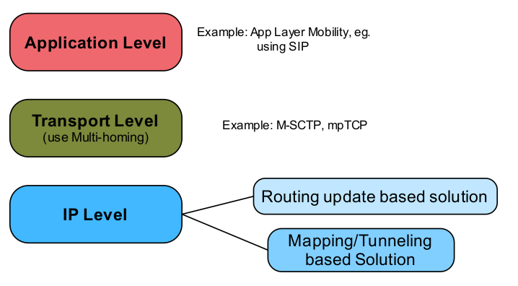

Multipath TCP (mpTCP) The sender sends packets across multiple paths
MPTCP allows a single data-connection to use several interfaces simultaneously. Solves at transport layer
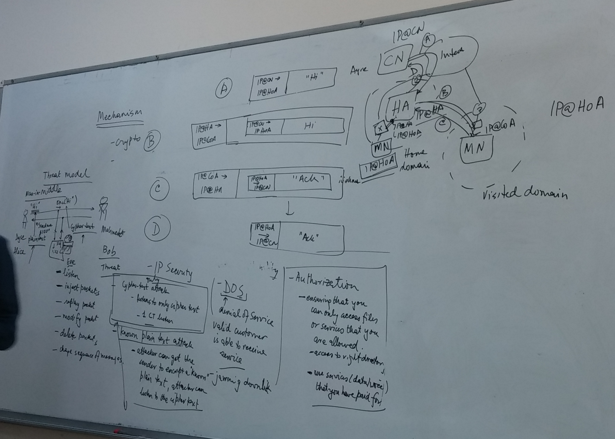
mobile IP

All handovers in LTE are prepared handovers Æ Resources are prepared in the target eNB, before the UE connects to the target eNB. The source eNB decides as to which target eNB the UE should be handed over to and directs the UE to that particular target eNB.
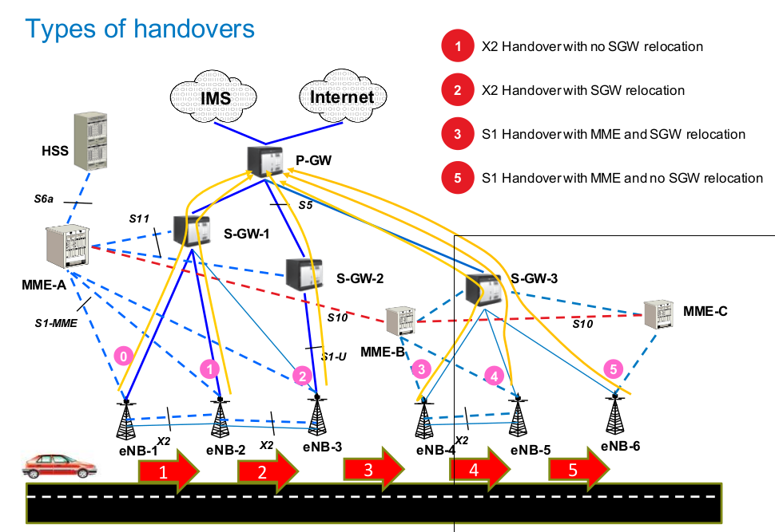

Power Conservation in UE
High Power: “Connected Mode” when UE has both its transmitter and receiver always on. The UE is transmitting and receiving data from the network.
Low Power: “Idle Mode” when UE turns off it transmitter. It turns on its receiver periodically. Tracking Area Update. UE is only monitoring the paging and broadcast channel.
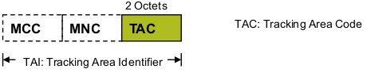
Larger the tracking area, less frequent will be the UE’s need to signal to the network; however larger the number of eNBs that the UE will need to be paged in.
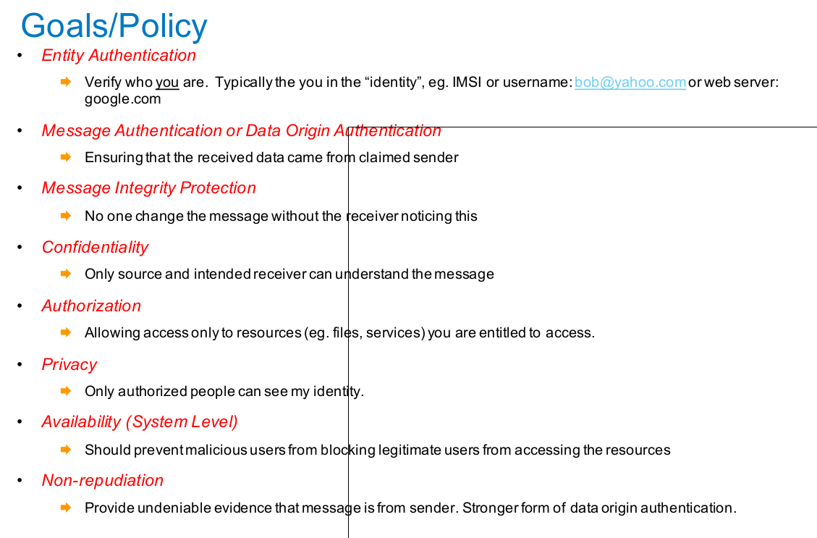

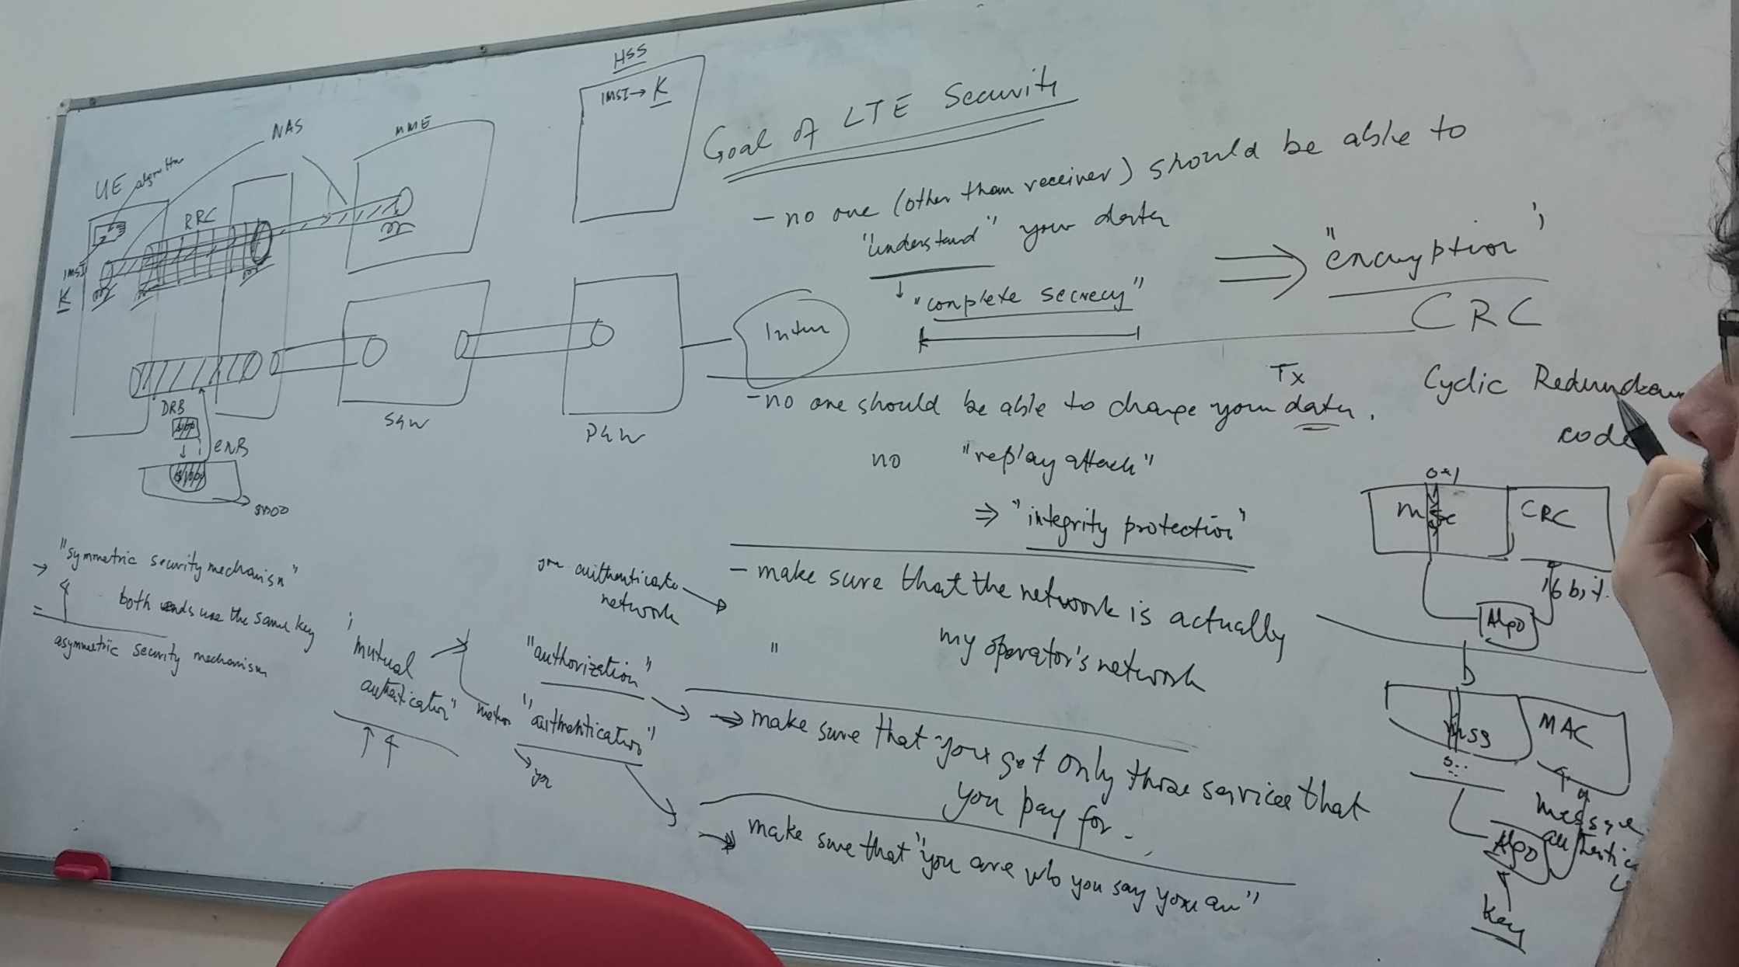

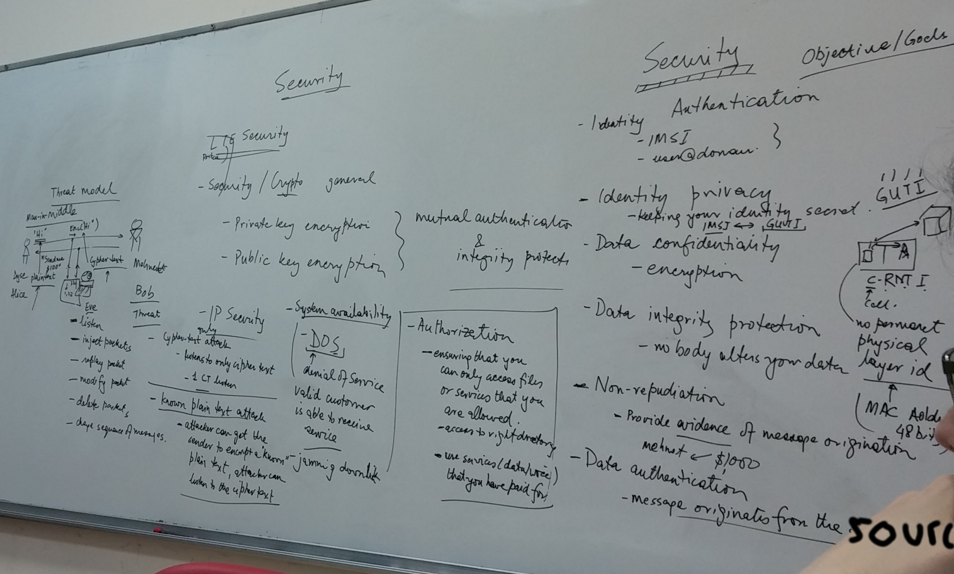
Man-in-the-middle attack
Listen Delay Delete Modify Create new message Replay message Change the sequence of messages

Symmetric key: uses same key at both ends (shared key) Æ Also called Private key scheme
Asymmetric key: uses two different keys (public and secret keys) ÆAlso called Public Key Scheme
Perfect Secrecy (or information-theoretic secure) means that the ciphertext conveys no information about the content of the plaintext.

• The two permanent identities of UE are: Æ IMSI (subscriber identity) Æ Seldom send over the air (only during attach, if no other valid temporary ID is present in the UE). Æ Temporary identities used instead (S-TMSI, GUTI) Æ IMEI (hardware identity) Æ Only sent to MME (in NAS), not to eNB. Æ Sent only after NAS security is setup (i.e encrypted and integrity protected).

